**Report Version:**

8/1/2017 OPORD

**ATTENTION: Please read this full document to avoid miscommunication or organizational issues.**

**Operation Summary:**

The town of Charlottesville, Virginia has recently become a flashpoint in the culture war against the anti-white and anti-free speech left with the town trying to take down or alter civil war monuments. Earlier this year, the Alt Right held a secretive rally in the town to protest again these policies which gained international coverage and showed a serious maturity with various groups working together. Since this event the left and the city has not gotten the message, and continue to harass local journalist Jason Kessler and his friends for their point of view on the issue. On August 12th we plan on going back to Charlottesville to show them that they are not unopposed with a rally that brings together with various right wing groups to show solidarity on issues we overlap with as well as show support for locals afraid to speak up. This rally, like the Battle of Berkley, will be a chance to show the left in one of their central power hubs that they will no longer go unopposed like they are used to with older generations of right wingers. Originally, we intended for this rally to be made up of Alt Right and Alt Lite figures, but many Alt Lite figures have since pulled out. This is not a major issue since this is shaping up to be the largest Alt Right/WN event in recent history.

Please read this entire document so you know all the details of the event. If you have any questions please ask in the “questions_for_coodinators” chat of the Discord and tag coordinators.

**Friendlies:**

We are expecting to have between 800-1400 friendly people attend this rally ranging from Alt-Lite, Oathkeepers, Proud Boys, and Trumpists to Identitarians, Neo-Confederates, national socialists and other Alt Right groups.

Anyone who is coming and not part of an already existing group should be directed to the Free Agent Liaison.

**Enemies/Counter Protestors:**

We have been monitoring Antifa and other leftist activities for months leading up to the event and are anticipating between 1500-3000 counter protestors. These groups range from local Charlottesville residents or students from UVA to full fledged Antifa members.

Also, there are the potential of enemies within the right from our own ranks. Various Proud Boys and White Nationalist groups are coming to the event as opposition in unknown numbers with unknown intentions.

On Thursday, 10th of August we will release a list of High Value Targets through the chain of command of our security team identifying members of both groups opposed to the rally.

**Discord:**

Assume the Discord is entirely compromised. Our intel suggests that Antifa have someone monitoring this server for information. Eli Mosley removed one of them the night of 8/1/2017.

We are coming down to the wire of the event soon and should try to keep the Discord as clean as possible from shitposting so that people can communicate and organize what they need to for the rally.

**Overall Event Timeline:**

All times subject to change based on circumstances.

Friday 8/11 – Torchlight Demonstration

1630: Rally at “Nameless Field”, Charlottesville, VA

1700: Step off from “Nameless Field” towards Jefferson Monument on UVA campus

1715-1730: Conduct torchlight demonstration

1730-1745: Head back to “Nameless Field” and go back to cars.

Saturday 8/12 – Unite the Right Rally, Lee Park

900-930: ADVON Team Arrives on site

1000: Permit starts, ADVON Team starts taking the ground and securing the perimeter

1100-1130: Sound system setup

1200: Rally Begins

Music

Speakers

Close

1430-1500: Start heading to Police protection point off site

1500-1600: Travel back to rally points from police protection point

Saturday 8/12 – After Party Dinner and Speeches

1700-1800: Arrival to after party

1900: Speakers begin

**Equipment:**

Firearms – We will not tell anyone they cannot carry firearms at this rally, but we will stress that it MUST be done so in a lawful manner in accordance with VA State laws. If you have questions ask in the VA State Laws channel for help.

Poles/Flags – We have no received confirmation from the police department with clarification on this but will update this on the next document.

Shields – Groups are encouraged to bring their own shields but you should realize they may be confiscated by the police. We’ve been given mixed messages on what is and is not authorized.

Knives/Tasers – We have been informed that most knives and all tasers will not be allowed on the grounds that day. Anyone seeing a knife should report it immediately.

Pepper Spray – Pepper Spray is a hard one to know in VA and we are still waiting for confirmation on the rules for this. Will update next document.

Water Source – EVERYONE must have a water source this day. We cannot stress enough how hot it could be and if we run out of cups for water we don’t want to see anyone pass out.

**Roles and Directors:**

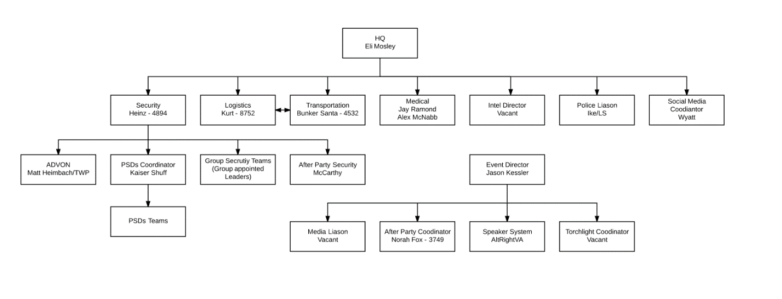

The above chart shows the current breakdown of chain of command for the day of the event. Eli Mosley will be between the HQ and on the ground while communicating between the various directors and leadership. Any role listed as Vacant must still be filled and you should reach out to Eli Mosley before August 6th to be assigned a role.

Intelligence Director – This role will manage the various intelligence teams that will need to gather intel leading up to the event, during the event and manage the intel/doxing after the event. This person should not be in attendance to the event and have some experience. They will be forwarding relevant intel into HQ.

Media Liaison – This role involves being the main point of contact for the media on the ground for the event. Several media outlets have confirmed that they are coming and this person would help them get in touch with people they’d like to interview and where they should be during the rally.

Torchlight Coordinator – This role will plan out the details of Friday night’s torchlight march and work with Jason Kessler on making sure we have everything ready for that night.

More roles may be needed as well so stay tuned into the Discord in case you are able to step up into other roles not listed here.

The Director role is immediately under HQ/Eli Mosley and Jason Kessler. The following list details their areas of responsibilities for the event (If anything is already being done and left out please inform Eli Mosley):

Security – Coordinate the various security team leaders, PSD teams and event security for the day. Manage the security shifts for both “gates” we’ll be having into the park. Provide the security plan for the scouting/ADVON team, during the rally, and the after party. Work with the Transportation Division on providing security during the rally for the moving vehicles. Brief the security teams on rules of engagement, equipment use, descalations, and the plan for the operation. Work with various security team leaders from groups attending the rally to assign them sections of the defensive perimeter.

Logistics – Work with the various directors on acquiring materials for them to complete their duties. Work with the Transportation Division on getting materials on the ground at the rally. Acquire leftover materials for the medical team.

Transportation – Main task will be helping to coordinate transportation between Trans Rally Points and Main Rally Point during the rally. Will work with the Logistics team to get supplies on the ground of the rally and get them out. Bring in and out the sound system for the rally and the after party. Help pick up and move stragglers if needed from Trans Rally Points.

Medical Team – Will setup a medical tent on the park grounds, provide basic triage that day, keep water supply, medical supplies and ice sheets. Liaison with emergency services on the ground directly.

Intel/Social Media Directors – This role should not be in attendance and will meet with Eli for details.

Police Liaison – Will work with various police departments in sending and receiving messages directly.

**Contact Information:**

Leading up to the event I am releasing my direct contact information to leaders and directors. I am in the middle of a move, but feel free to message me directly for anything regarding the event.

Eli Mosley – Discord, Eli Mosley#5269 – Phone Number, 610-406-2229 – Email, [DeplorableTruth@gmail.com](mailto:DeplorableTruth@gmail.com). Feel free to msg/call whenever.

**Torchlight Rally:**

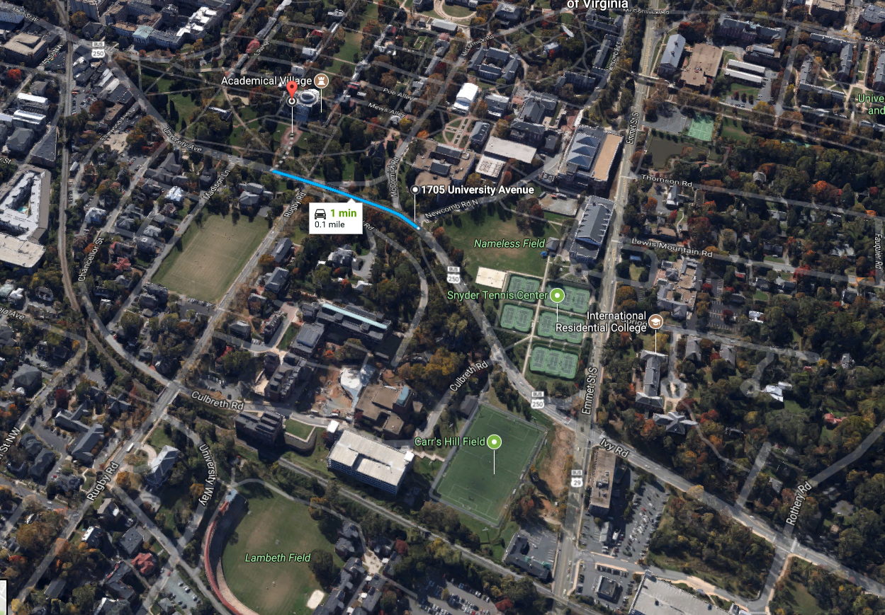

The Torchlight Rally will be at the Jefferson Monument near the UVA campus on Friday the 11th under cover of darkness. We will meet at 1630 in “Nameless Field” and march with our torches lit along the blue line. Each person should bring their own torch which can be bought from a local Wall-Mart, Lowes, Home Depot, etc. Once on the grounds of the monument we will sing a song or two, a speech will be given and then we will march the way we came before heading back to our cars.

**Pre-Rally and Transportation:**

Matthew Heimbach and TWP will handle the scouting of the rally grounds. We should have scouts check the area the night before and the morning of since we have received information that counter protestors perhaps intend to seize the area first.

The details of the transportation plan will be released Thursday before the event. However, the general plan is that we will have Transportation Rally Points scattered throughout the outskirts of the town where people may park. We will then have the Transportation team shuttle people from those points to the main police protected point in the town. Once we have large enough groups massed at the protection point police will escort us directly to the park and rinse and repeat until we get all our people there.

**During the Rally:**

The police have informed us that they can escort us from a main defensive area to the actual Lee Park grounds like they did for the KKK rally previously. We are still waiting to hear back from the police on which location they would like to protect centrally so that we can escort our people safely to the park. They intend on shutting down many of the streets around the park as well.

The police will be forming a buffer zone between us and the counter protesters while we form a perimeter to protect the park. While we secure the area with assigned shielded security around the VIPs and the inner circle of the rally. More details on the exact plan and rules of engagement to come out in next report.

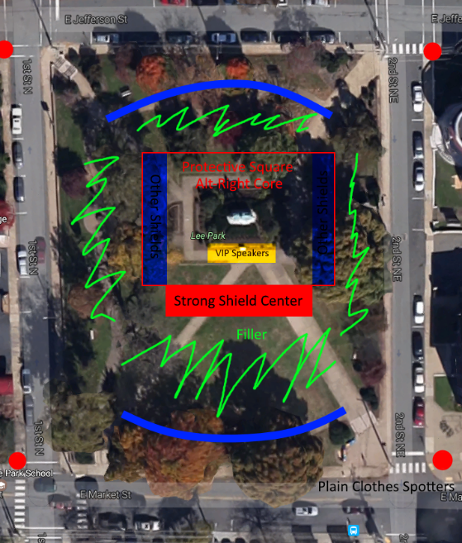

**During the Rally (if you cannot go or for Women):**

For anyone who cannot attend the rally but will be in Cville we will have two different things for you to do. We’ll need volunteers to help man the radios and HQ section. Also, we see a high likelihood of violence during the rally so we recommend not bringing women and are banning all small children. We will have a place set aside for them to help setup the after party and monitor streams that will be released Thursday before the event.

**After-Party for Event:**

We are keeping the details of where exactly the after party is secret for now, but we can say that its about 20-30 minutes outside of Cville to prevent any leftist attacks. There will be some food, places too cookout, beer/drinks, live music, and a surprise speaker or two. The information for the after party will be released in more details on Thursday before the rally.

To buy a ticket to the party beforehand is $12 which is used to provide the food and rental equipment. You may use [THIS](https://www.paypal.com/cgi-bin/webscr?cmd=_s-xclick&hosted_button_id=EYYVED94XL8U2) link to send the money through PayPal. Send a note with your payment letting us know what name or email you want on the guest list. If you do not pay beforehand, tickets will also be available at the door.

**Conclusion:**

The next order will be released Sunday night the 7th and then a follow up on Thursday the 10th with more details. We are assuming the Discord is compromised so we will be including a “general public guide” once leaders and directors go over this one with less information. If you have questions or need a correction made please message Eli Mosley. Finally, I realize I’ve been hard to get a hold of lately but I should be easier to get a hold of starting Thursday August 3rd once I am finished with my move.